Gennady Rubinstein, M.D.
Diplomate, American Board of Dermatology
Eric Lovato, PA-C
Karen Landy, NP-C

kybella®
TREATMENT FOR REDUCTION
OF SUBMENTAL FAT OR “DOUBLE CHIN”
If you suffer from a double chin, you’re not alone! According to a survey conducted by the American Society of Dermatologic Surgery, 68% of patients are bothered by their double chin, which can certainly ruin a good selfie! The good news is that we are now offering the first and only FDA-approved injectable medication that contours and improves the appearance of moderate to severe submental fullness, sometimes referred to as “double chin.” To learn more about submental fullness or this new treatment, contact our office to schedule a consultation.
Price breakdown per 2.0cc vial | $ Cost per vial | Recommended # of vials | Total Cost  (may vary depending on individual response to treatment)
1 | 800
2-6 | 600
7-10 | 560
10-12 | 540
12+ | 500
KYBELLA® (deoxycholic acid) injection, contours and improves the appearance of moderate to severe submental fullness, sometimes referred to as “double chin.”
Submental fullness can impact a broad range of adults, including both men and women, and can be influenced by several factors such as aging, genetics and weight gain and is often resistant to diet and exercise alone. According to a survey by the American Society for Dermatologic Surgery, nearly as many consumers are bothered by submental fullness (68%) as by lines and wrinkles around the eyes (71%).
When injected into subcutaneous fat, KYBELLA® causes the destruction of fat cells. Once destroyed, those cells cannot store or accumulate fat.
The most common side effects are swelling, bruising, pain, numbness, redness and formation of small areas of firmness around the treatment area.
Talk to Dr. Rubinstein or one of our knowledgeable staff members to determine if KYBELLA® might be right for you, or learn more about KYBELLA™ visit www.myKybella.com.

Patient Name: _________________________ Date: __________by: _______
How much does Kybella treatment cost?
Severity | Average # of vials | Average # of Visits | Frequency | Average Cost
Mild to Moderate | 6 | 3 | 4-6 weeks | $3,600
Moderate to Severe | 9-12 | 3-4 | 4-6 weeks | $5,000
Add Ultherapy to define the jaw line | 10% OFF lower face treatment  ($2,250 to $2,790)
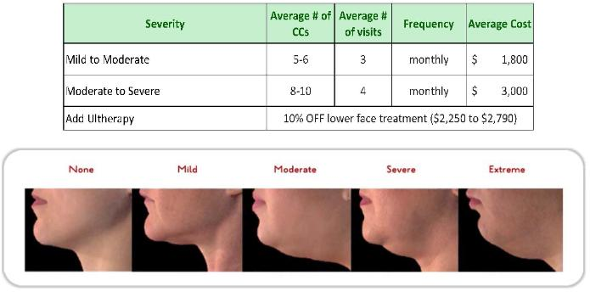

Studio City www.LAskinMD.com Simi Valley
(818) 505-9300 (805)522-3300

kybella®
Frequently ASKED QUESTIONS

What is kybella?
KYBELLA® (deoxycholic acid) injection is the first and only FDA-approved injectable treatment that is used in adults to improve the appearance and profile of moderate to severe fat below the chin (submental fat), also called, “double chin.” It is not known if KYBELLA® is safe and effective in children less than 18 years of age. It is not known if KYBELLA® is safe and effective for use outside of the submental area.

How does kybella work?
The active ingredient in KYBELLA® is deoxycholic acid, a naturally-occurring molecule in the body that aids in the breakdown and absorption of dietary fat. When injected into the fat beneath your chin, KYBELLA® causes the destruction of fat cells. Once destroyed, those cells cannot store or accumulate fat.
How many people have been treated with kybella?
KYBELLA® has been the focus of a global clinical development program involving over 20 clinical studies with more than 2,600 patients worldwide, of which over 1,600 have been treated with KYBELLA®.
- In clinical studies, results for KYBELLA®-treated patients who had a ≥1-grade composite improvement were 8% (1 treatment), 28% (2 treatments), 43% (3 treatments), 55% (4 treatments), 66% (5 treatments) and 72% (6 treatments)
- In clinical studies, results for KYBELLA®-treated patients who had a ≥2-grade composite improvement were 0% (1 treatment), .2% (2 treatments), 0.8% (3 treatments), 3.5% (4 treatments), 3.9% (5 treatments) and 15% (6 treatments)
- 59% of subjects in the clinical trials received all 6 treatments

Studio City www.LAskinMD.com Simi Valley
(818) 505-9300 (805)522-3300

Will I experience any side effects?
The safety profile of KYBELLA® is well characterized. The most common side effects are swelling, bruising, pain, numbness, redness and areas of hardness around the treatment area. KYBELLA® can cause serious side effects, including trouble swallowing and nerve injury in the jaw that can cause an uneven smile or facial muscle weakness. Most side effects are temporary and may last days, weeks or months. These are not all of the possible side effects of KYBELLA®. Some side effects may be permanent, but it is uncommon. Ask your healthcare provider for medical advice about side effects.
How many treatments will I need?
You and your Health Care Provider (HCP) will customize your KYBELLA® treatment regimen, including how many treatments you need, based on your desired chin profile. Many patients experience visible results in 2 to 4 treatment sessions. During these sessions, your HCP will administer KYBELLA® into the fat under your chin using multiple injections. Up to 6 treatment sessions may be administered spaced no less than one month apart.
Is KYBELLA treatment painful?
Treatment involves a series of injections. Topical numbing ointment is the most common method of anesthesia for KYBELLA injections.
When can I expect to see results from KYBELLA treatment?
Because it takes time for your system to absorb the fat cells that have been affected by KYBELLA, allow several weeks after your last treatment to see final results. Six to 12 weeks is common, even though some patients will respond sooner. Proper hydration is always important for healthy lymphatic drainage.
How long will the results last?
When injected into the fat under your chin, KYBELLA® causes the destruction of fat cells. Once destroyed, those cells cannot store or accumulate fat. After the aesthetic response is achieved, retreatment with KYBELLA® is not expected.

