PicoSure

PicoFacial and PicoTone

PicoSure is a quick and easy non-surgical, non-invasive laser skin treatment for those seeking a more youthful appearance, clearer skin tone and texture. PicoSure laser can treat many areas of the body including chest or décolleté, face, hands, legs, and more. Patients have also experienced great results for the treatment of acne scars, pigmented lesions and fine lines. Impressive results are achieved without the typical downtime or discomfort.

How does PicoSure work?
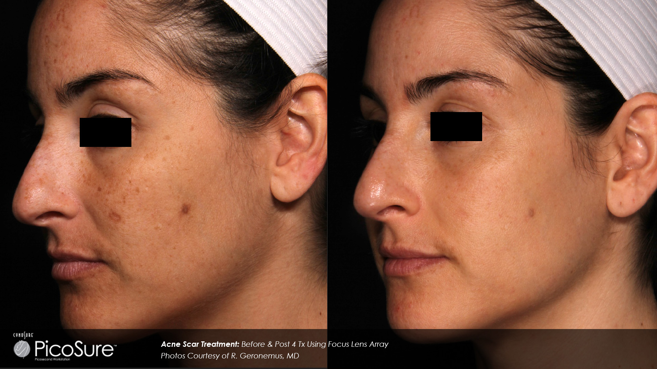
PicoSure laser focuses on your problem areas including brown spots, sun damage, freckles, pigmented lesions or acne scars. PicoSure offers a gentler treatment. In the past, lasers have relied on intense heat energy to remove pigment from the skin, which may be painful and lead to significant skin redness and downtime. The PicoSure laser emits a picoseconds pulse which is one trillionth of a second long. It works by “exploding” and breaking up pigment particles into small enough fragments that the body absorbs within several weeks.
Before and after 4 treatments

Why PicoSure Laser Treatment?
PicoSure works on the deeper structures of the skin targeting the pigment where it resides in the deeper layers of the skin. Patients with residual pigment after IPL or other laser treatments may benefit from PicoSure laser treatment to target deep residual pigmentation. A first step to achieving a more youthful appearance, or just tweaking some trouble-spots, PicoSure laser treatments offer significant laser rejuvenation with minimal downtime.

About the PicoSure Treatment:
Depending on your target problem areas as well as the recommended treatment protocol for the individual condition of your skin, PicoSure treatments are performed in a series of 3 to 6 treatments every 2 to 4 weeks. Results are gradual as the skin regenerates and works the pigment out. Good health, hydration and skin care products, including antioxidants, peptides, lightening agents and sunscreen are important in this time to help the skin resorb the destroyed pigment particles. The skin may feel flushed for one to three days and target spots that are treated in a deeper manner may appear red or brown for several days. General risks from this treatment are very low. The treatment is virtually painless and only topical anesthesia is recommended.

PicoTone vs. PicoFacial
PicoTone is a total skin rejuvenation treatment which targets multiple conditions including pigmentation, fine lines, enlarged pores and general tone and texture of the skin. This treatment is performed in a series of 3 to 5 sessions and includes the entire area. A fractionated, focused laser modality is used for this overall treatment. A PicoFacial is a treatment designed to target melasma and stubborn, deep pigmentation. A series of 4 to 6 sessions two to four weeks apart is recommended and follow up single sessions are recommended as soon as pigment begins to re-appear. Because of the nature of melasma pigmentation, ongoing treatments to help maintain results are recommended.
Speak with one of our consultants or providers to see if this treatment is right for you!

PicoSure Fee Schedule:

 |  | PicoSure | Dr. Rubinstein |  | Physician Assistant / Laser Nurse
 |  | PicoTone  Rejuvenation  (2-4 weeks apart) | Single Session | Series  of 4 | Single Session | Series  of 4 | Series  of 6 | Additional future treatments after a series
 |  | Face | 600 | 2,100 | 600 | 2,100 | 3,200 | 500
 |  | Face/Neck | 750 | 3,000 | 750 | 2,700 | 3,750 | 650
 |  | Face/Chest | 800 | 3,200 | 750 | 2,700 | 3,750 | 650
 |  | Face/Neck/Chest | 900 | 3,250 | 900 | 3,100 | 4,500 | 750
 |  | Neck/Chest | 700 | 1,890 | 700 | 1,750 | 3,500 | 650
 |  | Chest | 600 | 2,100 | 500 | 1,800 | 3,000 | 500
 |  | Hands/Feet (both) | 350 | 1,000 | 350 | 945 | 1,400 | 280
 |  | Lower arms/legs  (not including hands) | PA/RN only |  | 600 | 2,000 | 3,200 | 500
 |  | Arms: Full arms/legs  (not including hands/feet) |  |  | 900 | 3,100 | 4,500 | 750
 |  | Spots – up to 10 min treatment (Free with any series of 3 or more) |  |  | 250
 |  | PicoFacial  Melasma  (2-4 weeks apart) |  |  | Single Session | Series  of 4 | Series  of 6 | Additional future treatments after a series
 |  | Face |  |  | 300 | 1,100 | 1,500 | 250
 |  | Forehead or cheeks only |  |  | 250 | 900 | 1,275 | 225
 |  | Upper lip only |  |  | 250 | 900 | 1,275 | 225
Speak with one of our consultants or providers for your individualized treatment protocol.

Your PicoSure appointment is scheduled as follows:
Date: _____________
Arrival Time: __________AM/PM
Procedure Time: ___________ AM/PM
Provider: ______________________

Cost Estimate: __________________
Deposit Paid: $_____________ on: ________
Amount due prior to treatment: $_________
by: _______________

Full payment and 48 hour cancellation notice is required. Same day cancellation fee is $100.

