Platelet Rich Plasma

Science & Data
As part of the body’s healing ability, platelets and other components in human blood migrate to the point of care. Platelets are well known to release numerous growth factors that respond to tissue injury and initiate and promote the conditions for healing. Eclipse PRP® is an autologous system that allows physicians to prepare platelet-rich plasma at the patient point of care. This system has been safely used in hundreds of thousands of procedures worldwide.

Platelets Release Growth Factors

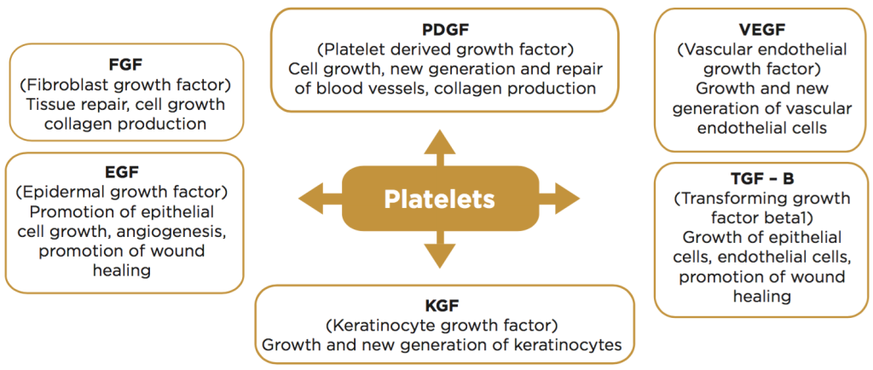

Description of treatment

This treatment involves the collection of your blood (approximately 8 – 16ml), then your blood is spun down using a centrifuge to separate out the plasma and platelet portion using the separator gel’ as a special filter. The PRP portion of your blood is then injected back into your skin to stimulate new collagen production, and to re-energize your cells into rejuvenating themselves. The product injected is 100% your own blood by-product (autologous). PRP is most often combined with microneedling or laser resurfacing which creates microcolumns in the skin and promotes penetration of the PRP. Microneedling and fractionated laser resurfacing also contributes significantly to skin renewal and collagen remodeling.

After PRP: you will likely experience mild to moderate swelling of the treated area, this will last for about 12- 24 hours; ice or cold compresses can be applied to reduce swelling if required. You may notice a tingling sensation while the cells are being activated. In rare cases skin infection may occur, which is easily treated with an antibiotic.

BENEFITS of PRP
Along with the benefit of using your own tissue therefore eliminating allergies there is the added intrigue of mobilizing your own stem cells for your benefit. PRP has been shown to have overall rejuvenating effects on the skin as in: improving skin texture, fine lines and wrinkles, increasing volume via the increased production of collagen and elastin, and by diminishing and improving the appearance of scars. Other benefits: minimal down time, safe with minimal risk, short recovery time, natural looking results, no general anesthesia is required.

How Much Blood will be Used?
We collect one tube, which varies between 8 to 16ml. Due to the natural variation in quality of Platelet rich plasma, volume will vary between individuals and is dependent on patient's blood volume and ability to extract platelets. The amount of blood collected is not directly proportional to the amount of platelets that can be extracted through the Eclipse PRP Autologous system. Individual PRP volume may vary. We recommend preparing for treatment by hydrating and avoiding alcohol consumption. Your injector will make treatment decisions based on volume extracted to maximize your individual results for effective treatment.

How Many Treatments are Required?
Depending on the condition which is being treated, 3 to 6 sessions may be required with an interval of 4 to 12 weeks.

When Can I Expect to See Results?
Hair Loss: Results from treatment for hair loss, may take several months as the hair slowly begins to grow. You may first notice less hair loss, which is a good indication of the efficacy of treatment. Dormant hair follicles start producing hair slowly as they become stronger. Areas with no active hair follicles may not respond, or may take additional treatments. Your provider will assess the skin before every treatment to determine the response.

Rejuvenation: You will notice improved skin tone and texture within 4 to 6 weeks after every treatment. A series of treatments is recommended with regular intervals, After which time maintenance treatments are recommended to maintain results as the skin ages.

Scars and Acne Scars: The nature of scarring is such that every scar responds differently. We often customize every treatment, utilizing a combination of PRP with MicroNeedling and/or various lasers to address different forms of scarring. A series of treatments may include a combination of modalities as the scars heal and the skin is regenerated.

CONTRAINDICATIONS, RISKS & DOWN TIME
PRP used for aesthetic procedures is safe for most individuals between the ages of 25‐80. There are very few contraindications, and side effects. PRP is often used to decrease down time of invasive laser procedures. A consultation with one of our providers will help determine if you are a candidate for PRP and all the risks and benefits will be discussed.

Platelet Rich Plasma treatment includes blood draw. Volume is dependent on patient's blood volume and ability to extract platelets. Volume may vary. | Dr. Rubinstein  Eric Lovato PA |  |  |  | Karen Landy, NP |  |  |  | Maintenance Treatment (after initial series as recommended within 1 year)
 | one session | 4  sessions | 6 sessions | Save on 6 | one session | 4  sessions | 6 sessions | Save on 6
PRP per vial  (hair loss,  other injectible only) | 900 | 3,200  ($800 each) | 4,500  ($750 each) | 900 | 800 | 3,000  ($750 each) | 4,200  ($700 each) | 600 | 750
PRP with Microneedling/Injectible | 1,250 | 3 -$3,850  4- $4,400 | 6,375 | 1,125 | 1,100 | 3 -$2,900  4- $3,800 | 5,280 | 1,320 | 1,000
Extra area/vial PRP | 600 | 1,620 | 3,060 | 540 | 500 | 1,275 | 2,400 | 600
Extra area PRP+MN | 750 | 2,025 | 3,825 | 675 | 750 | 1,913 | 3,600 | 900 | 600
Microneedling | 500 | 1,350 | 2,500 | 500 | 350 | 800 | 1,500 | 300 | 400 / 300

Recommended # of vials | Total Cost

Your PRP appointment is scheduled as follows:
Date: _____________
Arrival Time: __________AM/PM
Procedure Time: ___________ AM/PM
Provider: ______________________
Cost Estimate: __________________
Deposit Paid: $_________ on: ________
Amount due prior to treatment: $_________
PREPARING FOR YOUR TREATMENT
- Hydrate – Please drink at least 64 oz of water each day for 3 days prior to your procedure and on the day of your procedure before you arrive. (32 oz if your procedure is in the morning).
- Sun Exposure - avoid for one week before and 2 weeks after procedure
- Alcohol – limit for 3 days
- Caffeine - Limit or avoid, if possible, on the procedure day.

Full payment and 48 hour cancellation notice is required. Same day cancellation fee is $100

